**Coffee Beans**

***RevEng***

**Challenge:**

Can you decompile me?

Attached - decompileMe.class

**Approach:**

The .class points me towards the fact that it is a java code, you can check that if you open it in a notepad as well.

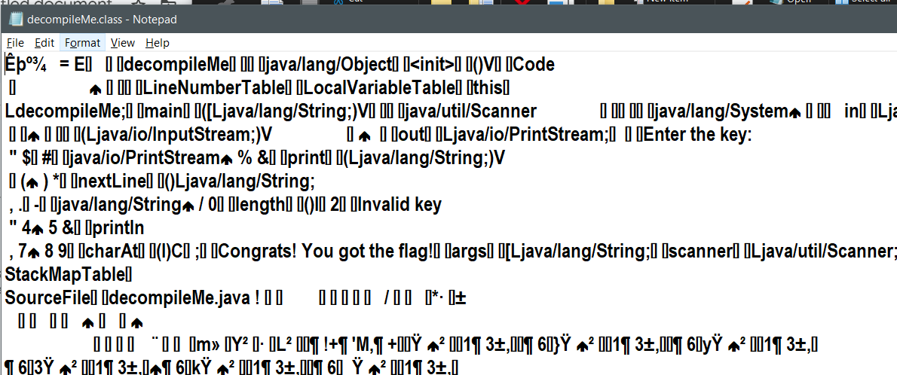

We use a online java decompiler such as javadecompilers.com and we get the java code.

Analyzing the code is easy if you understand basic programming syntaxes. We build up the flag char by char, and it comes out to be:

**Flag: CTFWU{5h1ny_k3y}**

Congrats!!

Happy Hacking!